DESIGN & ANALYSIS OF ALGORITHMS (10CS43)

UNIT-VIII

PRAM ALGORITHMS:
Introduction
Computational Model
Parallel Algorithms for
- Prefix Computation
- List Ranking
- Graph Problems

COMPUTATIONAL MODELS
The most popular computational model is the Parallel Random Access Machine (PRAM) which is a natural generalisation of the Random Access Machine (RAM).
The PRAM model consists of p synchronised processors P1, P2, . . . , Pp, a shared memory with memory cells M[1], M[2], . . . , M[m] and memories of the processors.
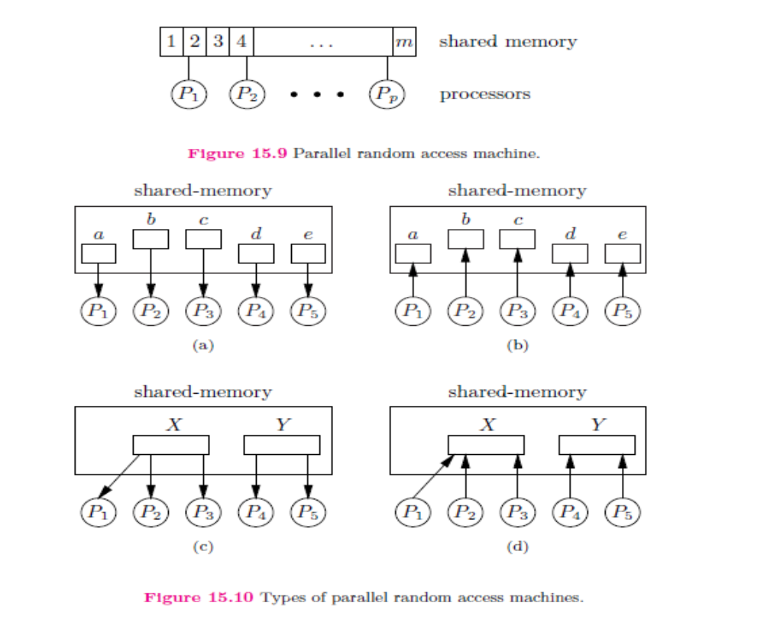
Figure 15.9. shows processors and the shared random access memory There are variants of this model. They differ in whether multiple processors are allowed to access the same memory cell in a step, and in how the resulting conflicts are resolved. In particular the following variants are distinguished:
Types on the base of the properties of read/write operations are
- EREW (Exclusive-Read Exclusive-Write) PRAM,
- ERCW (Exclusive-Read Concurrent-Write) PRAM,
- CREW (Concurrent-Read Exclusive-Write) PRAM,
- CRCW (Concurrent-Read Concurrent-Write) PRAM.
Figure 15.10(a) shows the case when at most one processor has access a memory cell (ER), and Figure 15.10(d) shows, when multiple processors have access the same cell (CW).
Types of concurrent writing are common, priority, arbitrary, combined.

MESH, HYPERCUBE AND BUTTERFLY
Mesh is a popular computational model. A d-dimensional mesh is an a1 × a2 × · · · × ad sized grid having a processor in each grid point. The edges are the communication lines, working in two directions. Processors are labelled by d-tuples, as Pi1,i2,...,id . Each processor is a RAM, having a local memory. The local memory of the processor Pi1,i2,...,id is M[i1, . . . , id, 1], . . . ,M[i1, . . . , id,m]. Each processor can execute in one step such basic operations as adding, subtraction, multiplication, division, comparison, read and write from/into the local memory, etc. Processors work in synchronised way, according to a global clock.
The simplest mesh is the chain, belonging to the value d = 1. Figure 15.11 shows a chain consisting of 6 processors.
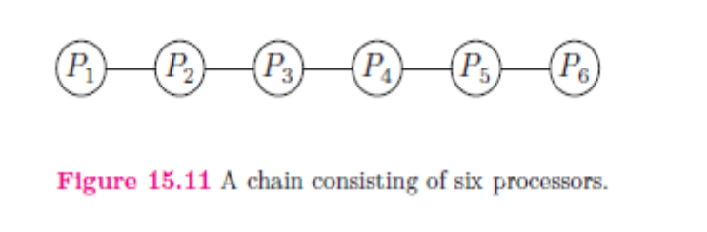
The processors of a chain are P1, . . . , Pp. P1 is connected with Pp−1, Pp is connected with Pp−1, the remaining processors Pi are connected with Pi−1 and Pi+1. If d = 2, then we get a rectangle. If now a1 = a2 = pp, then we get a square. Fig15.12 shows a square of size 4 × 4.
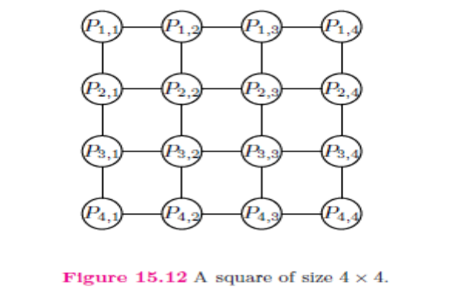

A square contains several chains consisting of a processors. The processors having identical first index, form a row of processors, and the processors having the same second index form a column of processors. Algorithms running on a square often consists of such operations, executed only by processors of some rows or columns.
If d = 3, then the corresponding mesh is a brick. In the special case a1 = a2 = a3 =3pp the mesh is called cube.

Figure 15.13 shows a cube of size 2 × 2 × 2.
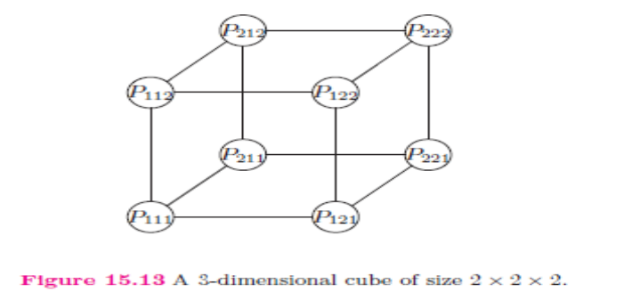
The next model of computation is the d-dimensional hypercube Hd. This model can be considered as the generalisation of the square and cube: the square represented on Figure 15.12 is a 2-dimensional, and the cube, represented on Figure 15.13 is a 3-dimensional hypercube. The processors of Hd can be labelled by a binary number consisting of d bits. Two processors of Hd are connected iff the Hamming-distance of their labels equals to 1. Therefore each processors of Hd has d neighbours, and the of Hd is d. Figure 15.14 represents H4.
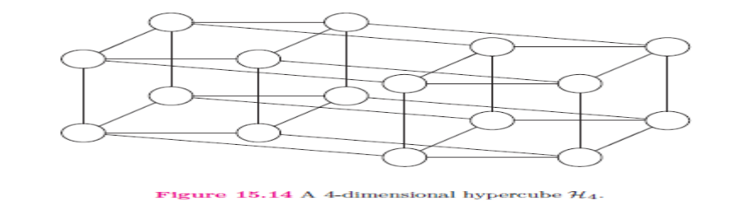
The butterfly model Bd consists of p = (d + 1)2d processors and 2dd+1 edges. The processors can be labelled by a pair hr, li, where r is the columnindex and l is the level of the given processor. Figure 15.15 shows a butterfly model B3 containing 32 processors in 8 columns and in 4 levels. Finally Figure 15.16 shows a ring containing 6 processors.
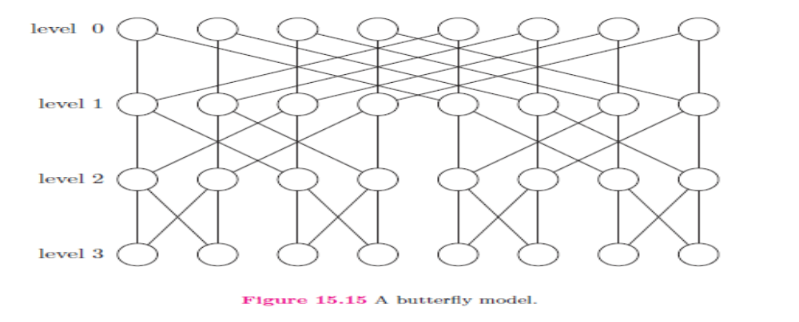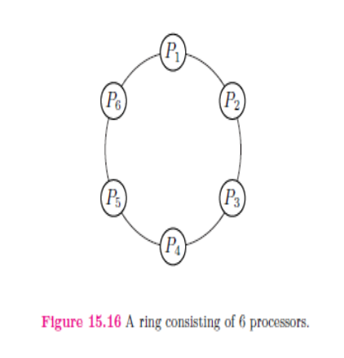
III. PARALLEL ALGORITHMS FOR

Prefix Computation
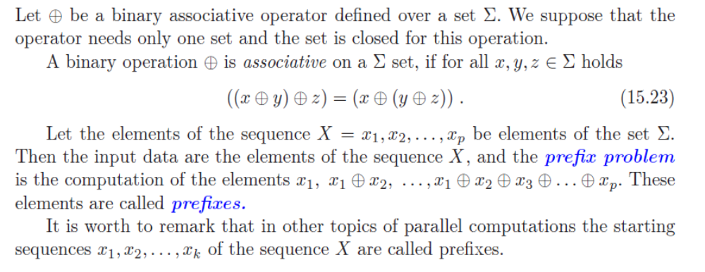

Example 15.1 Associative operations. If _ is the set of integer numbers, means addition and the sequence of the input data is X = 3,−5, 8, 2, 5, 4, then the sequence of the prefixes
is Y = 3,−2, 6, 8, 13, 17. If the alphabet and the input data are the same, but the operation is the multiplication, then Y = 3, −15, −120, −240, −1200, −4800. If the operation is the minimum (it is also an associative operation), then Y = 3, −5, −5, −5, −5, −5. In this case the last prefix is the minimum of the input data.
The prefix problem can be solved by sequential algorithms in O (p) time. Any sequential algorithm A requires (p) time to solve the prefix problem. There are parallel algorithms for different models of computation resulting a work-optimal solution of the prefix problem.
In this subsection at first the algorithm CREW-Prefix is introduced, which solves the prefix problem in _(lg p) time, using p CREW PRAM processors.
Next is algorithm EREW-Prefix, having similar quantitative characteristics, but requiring only EREW PRAM processors. These algorithms solve the prefix problem quicker, then the sequential algorithms, but the order of the necessary work is larger.
Therefore interesting is algorithm Optimal-Prefix, which uses only dp/ lg pe CREW PRAM processors, and makes only _(lg p) steps. The work of this algorithm is only _(p), therefore its efficiency is _(1), and so it is work-optimal. The speedup of this algorithm equals to _(n/ lg n).
For the sake of simplicity in the further we write usually p/ lg p instead of p/ lg p.

A CREW PRAM algorithm. As first parallel algorithm a recursive algorithm is presented, which runs on CREW PRAM model of computation, uses p processors and _(lg p) time. Designing parallel algorithm it is often used the principle divide-and-conquer, as we we will see in the case of the next algorithm too Input is the number of processors (p) and the array X[1 . . p], output data are the array Y [1 . . p]. We suppose p is a power of 2. Since we use the algorithms always with the same number of processors, therefore we omit the number of processors from the list of input parameters. In the mathematical descriptions we prefer to consider X and Y as sequences, while in the pseudocodes sometimes as arrays.
CREW-Prefix(X)
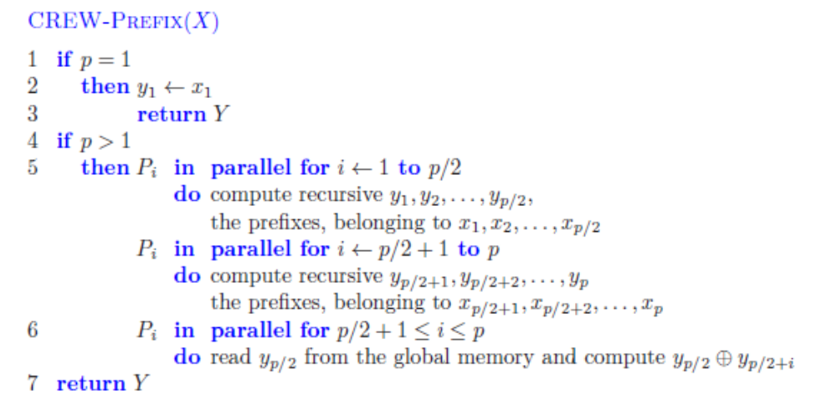
Example 15.2 Calculation of prefixes of 8 elements on 8 processors. Let n = 8 and p = 8. The input data of the prefix calculation are 12, 3, 6, 8, 11, 4, 5 and 7, the associative operation is the addition. The run of the recursive algorithm consists of rounds. In the first round (step 4) the first four processors get the input data 12, 3, 6, 8, and compute recursively the prefixes 12, 15, 21, 29 as output. At the same time the other four processors get the input data 11, 4, 5, 7, and compute the prefixes 11, 15, 20, 27.
According to the recursive structure P1, P2, P3 and P4 work as follows. P1 and P2 get x1 and x2, resp. P3 and P4 get x3 and x4 as input. Recursively mean for P1 and P2, that P1 gets x1 and P2 gets x2, computing at first y1 = x1 and y2 = x2, then P2 updates y2 = y1 _ y2. After this P3 computes y3 = y2 _ y3 and y4 = y4 _ y4. While P1, P2, P3 and P4, according to step 4, compute the final values y1, y2, y3 and y4, P5, P6, P7 and P8 compute the local provisional values of y5, y6, y7 and y8.
In the second round (step 5) the first four processors stay, the second four processors compute the final values of y5, y6, y7 and y8, adding y4 = 29 to the provisional values 11,
15, 20 and 27 and receiving 40, 44, 49 and 56. In the remaining part of the section we use the notation W(n) instead of W(n, p) and give the number of used processors in verbal form. If p = n, then we usually prefer to use p.
A work-optimal algorithm. Next we consider a recursive work-optimal algorithm, which uses p/ lg p CREW PRAM processors. Input is the length of the input sequence (p) and the sequence X = x1, x2, . . . , xp, output is the sequence Y = y1, y2, . . . , yp, containing the computed prefixes.
